My self is Payal Bhatt, I am workinga s IT support Compancy: NHS Wales. Objectives: Career Enhancement, F/P - Both . City: Uk

**PR**oject **IN** **C**ontrolled **E**nvironment **2**

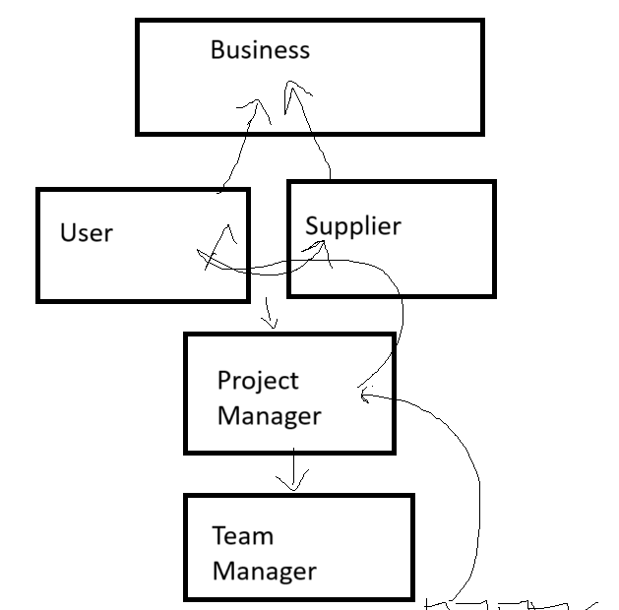

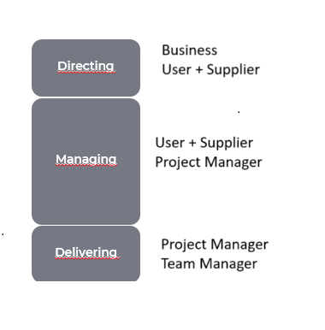

Change management:

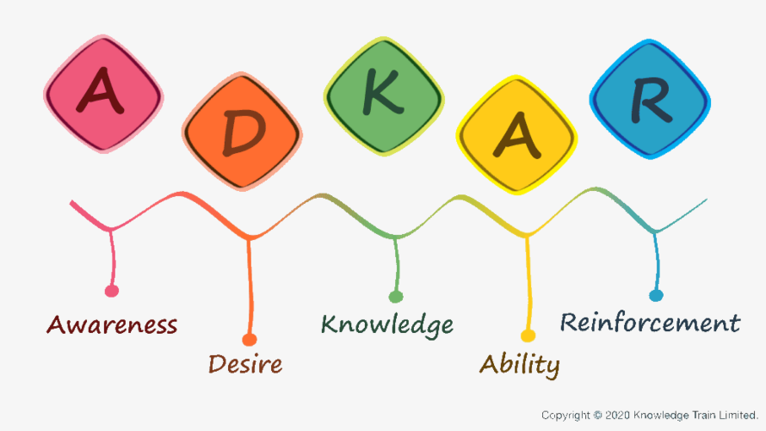

***Leading successful change:***

*ADKAR:* *A Framework for Successful Change*

[*https://www.youtube.com/watch?v=zXwJTZ2EA2Q&t=27s&ab_channel=KirstinMassey*](https://www.youtube.com/watch?v=zXwJTZ2EA2Q&t=27s&ab_channel=KirstinMassey)

*Kotter's 8 Step Change Management Model* - <https://www.youtube.com/watch?v=7qlJ_Y8w5Yk>

***Leading successful team:***

*Tuckman’s team formation model*

*Forming🡪 Storming 🡪 Norming 🡪 Performing 🡪 Adjourning*

There are different roles at each of the four organizational levels:

**Commissioning (the business layer)** Responsible for providing the project mandate, identifying the executive, defining the project level tolerances within which the project board will work, and determining whether to authorize any potential breach of a project level tolerance.

**Directing**  The project board has representations from the business, user, and supplier communities and is

accountable for the success of the project. It is also responsible for the overall direction and management of the project within the constraints established by the commissioning party.

**Managing** The project manager is responsible for the day-to-day management of the project within the constraints established by the project board.

**Delivering** Team managers and members are responsible for the day-to-day management and decision-making for their element of the project within the constraints established by the project manager, co-creating where required with other team members from across the project ecosystem.

Two other important roles may be assigned in different ways.

**Project assurance** Subject to who has the knowledge, skills, and capacity to support the project team, the assurance tasks can be undertaken by the board member themselves, appointed from the wider business, or selected from an external party. Where the project assurance roles are delegated, the project board member remains accountable.

**Project support** Can help with integration across the project ecosystem, but must be kept separate from project assurance roles to maintain the independence of assurance.

The purpose of starting up a project is to ensure that time is not wasted and that only viable projects are approved. Starting up a project involves identifying whether the project is worth initiating.

The decision to start the project must be explicit, as the activities within the process of starting up a project happen before this decision. The purpose of the process of starting up a project is to prevent poorly conceived ideas from ever being initiated. As such, starting up a project is a lighter process compared to the more detailed and thorough process of initiating a project.

**Business justification** initiates the project, as documented in an outline business case.

All the necessary **authorities exist** for initiation.

**Sufficient information** is available to define and confirm the scope of the project in a brief.

Evaluate the **project delivery methods** and select an approach.

**Identify** a **project team** and **appoint** individuals undertaking **project initiation planning** work and/or significant project management roles.

**Avoid wasting time** initiating a project based on unsound assumptions regarding scope, timescales, constraints etc.

The objectives of the initiating a project process ensure a common understanding of:

**Reasons**  Justification for the project, benefits expected, and associated risks.

**Scope**  The necessary work and the deliverable.

**Delivery**  How, when, and at what cost the product will be delivered.

**Decisions**  Who makes the project decisions.

**Quality**  How quality will be achieved.

**Baselines**  How baselines will be established and controlled.

**Risks**  How risks, issues, and changes will be identified, assessed, and controlled.

**Progress**  How progress will be monitored and controlled.

**Information**  Who needs information, in what format, and at what time.

**Application**  How the project applies business policies, methods, and guidance.

**CBA – Cost benefit analysis: (not for exam)**

Benefit/ Cost = more than 1 – take up the project ( 200/100) = 2

Benefit/ Cost = less than 1 – do not do the project (100/200) = 0.5

Benefit/ Cost = equal to 1 – Evaluate the hidden benefits and future gains =(100/100) = 1

Management products definition

**Project brief:** provides a full and firm foundation for project initiation

**Business case:** documents the business justification for the project, based on estimated costs against anticipated benefits and offset by associated risks

**Benefits management approach**: defines the benefits management actions and benefits reviews to be established to ensure outcomes are achieved and benefits realized.

**Sustainability management approach**: defines the actions, reviews, and controls established to ensure sustainability performance targets for the project are achieved.

Plans in PRINCE2

**Project plan** A high-level plan showing the major products of the project and when, how, and at what cost they will be delivered. The purpose of the project plan is to provide confidence to the project board that the project will fulfil its business case.

**Stage plans** A detailed plan used as the basis for project management control throughout a stage. A stage plan is prepared for each stage. The stage plan is similar to the project plan in structure, but each element is divided to the level of detail required for day-to-day control by the project manager.

**Team plans** A plan used as the basis for organizing and controlling the work of a team when executing a work package. Team plans are optional in PRINCE2. Their requirements and extent will be determined by the size and complexity of the project and the number of resources involved. Team plans are created in the managing product delivery process.

**Exception plans** A plan that follows an exception report and explains how the project will respond to the exception within the stage. Must be produced to show the actions required to recover from or avoid a forecast deviation from agreed tolerances in the project plan or a stage plan.

Quality cannot be measured

We have to make it measurable

**Coffee**:

Water = 75%

Milk =25%

Sugar =1

Coffee = 2

Temp = 80 DC

Quantity = 50 ml

Good bike:

Mileage = >= 70km /litre

Smooth gear shifting = 1 pedal touch

Less engine noise = less 5 decibel

Less vibration= less than 500 RPM

Low maintenance = less than $500 annually

Prober braking system = speed to braking distance ratio = 40 km/hr - 4 ft

5 meters for 50 km/hour

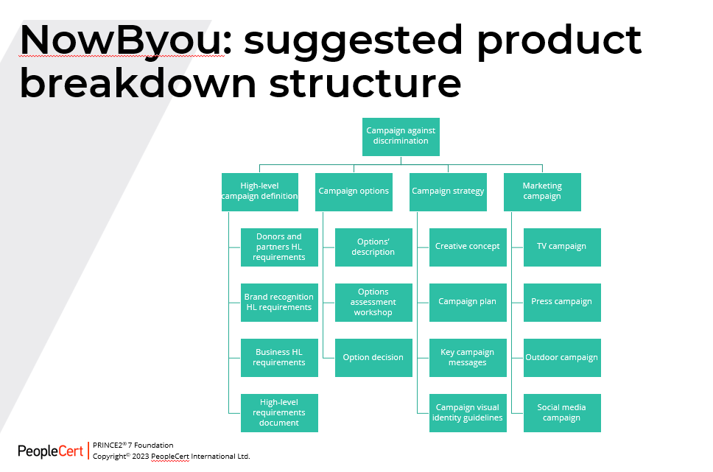

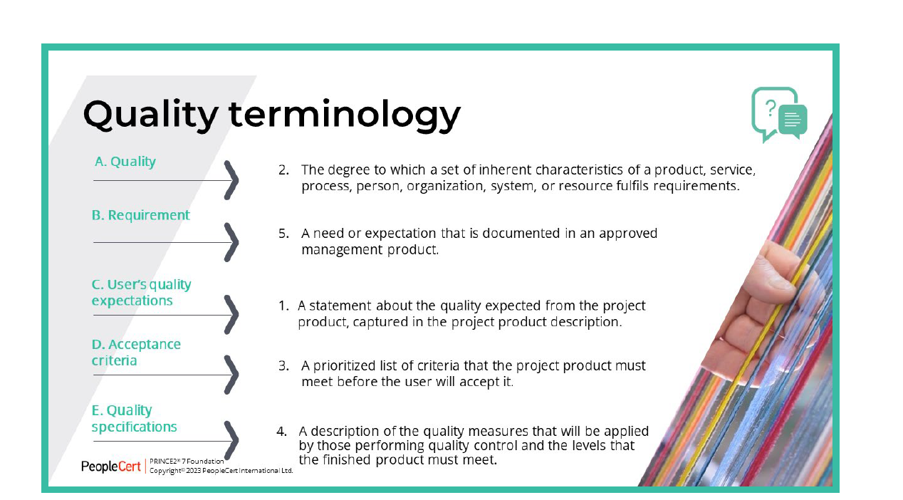

**Quality planning** Involves identifying the major products of the project and documenting them in terms of user’s expectations and acceptance criteria. It includes developing the quality management approach and obtaining board approval for these as a baseline.

**Quality control** Involves implementing the quality management approach, assessing quality issues and obtaining product acceptance.

**Quality assurance** Involves ensuring techniques are sufficient to confirm that quality requirements are met.

**Product description:** describes a product’s purpose, composition, derivation, and quality specifications. It is produced at the planning phase as soon as possible after the need for the product is identified.

**Quality management approach:** describes the quality techniques and standards to be applied and the roles and responsibilities for achieving the required quality specifications and acceptance criteria during a project.

**Quality register**: summarizes all quality management activities that are planned or have occurred, and is used for reviewing progress.

**Product register**: lists all products required of a plan and the status of those products.

**Example from Jasleen Bakshi** 12:05

1. **Awareness and EngagementSpecification**: Ensure at least 60% awareness among the target audience by mid-campaign. **Measurement**: Social media engagement metrics (likes, shares, comments), number of website visitors, and press coverage. **Permissible Deviation**: ±10% **Tolerance**: If engagement falls below 50%, consider adjusting messaging or increasing ad spend.
2. **Partnerships and Collaboration**Specification: Secure collaboration with at least 10 NGOs, community groups, or influencers. Measurement: Signed partnership agreements, joint events, or co-promotion activities. Permissible Deviation: ±2 partners Tolerance: If fewer than 8 partners are onboarded, re-evaluate outreach efforts or adjust partnership offerings.
3. **Fundraising and Budget**Specification: Achieve 50% of the fundraising goal by mid-campaign. Measurement: Total funds raised vs. the overall target. Permissible Deviation: ±15% Tolerance: If less than 35% of funds are raised, increase donor engagement or re-strategize fundraising efforts.

**Example from Ana-Maria Krusheva-Yordanova** 12:07

Advertisement on TV for the discrimination* animated infographic: in the style of (give 2-3 references for the visual style and the animation style)* clear message: define the message before the design starts* timely delivery: done in 5 days - from design to final product = 1,5 for design and 3 for animaion, 0,5 for feedback and fixes*permissible deviations: 0,3 days per stage to implement feedback

# Risk:

There are six response types as shown here and in more detail in Table 9.1.

**Avoid a threat/Exploit an opportunity** This option is about making the uncertain situation certain by removing the risk. This can often be achieved by removing the cause of a threat or by taking advantage of an opportunity. Where costs are incurred, these must be justified.

**Reduce a threat/Enhance an opportunity** This option involves a definite action now to change the probability and/or the impact of the risk. The term ‘mitigate’, making the threat less likely to occur and/or reducing the impact if it did, is relevant when discussing reduction of a threat.

**Optional: Elicit the meaning of mitigate**

Enhancing an opportunity is the reverse process (that is, making the opportunity more likely to occur and/or increasing the impact if it does). Response costs must be justified in terms of the change to residual risk.

**Transfer the risk (threat or opportunity)** Transfer is an option that aims to pass part of the risk to a third party.

**Optional: Elicit or provide an example: insurance is the classic form of transfer, where the insurer picks up the risk cost, but where the insured retains the impact on other objectives (such as time delay).**

**Share the risk (threat or opportunity)** Sharing the risk is an option that is different in nature from the transfer response. It seeks multiple parties to share the risk on a pain/gain share basis (typically within a supply chain).

**Optional: Elicit whether this is a common response and ask for a rationale or provide an example: risks are rarely entirely shared in this way (for example, the primary risk taker will always need to protect its brand and reputation).**

**Accept the risk ( threat or opportunity)** The accepting option means that the organization takes the chance that the risk will occur. In this case, the organization will accept the effect of the risk.

**Optional: Elicit an example or provide an example: the risk to profitability because of currency fluctuations. An organization may decide to take the chance and not engage in any hedging or other provision to protect margins from wide variation in rates.**

**Prepare contingent plans ( threat or opportunity)** A planned set of actions that will be taken for each risk.

**Avoid a threat/Exploit an opportunity** This option is about making the uncertain situation certain by removing the risk. This can often be achieved by removing the cause of a threat or by taking advantage of an opportunity. Where costs are incurred, these must be justified.

**Reduce a threat/Enhance an opportunity** This option involves a definite action now to change the probability and/or the impact of the risk. The term ‘mitigate’ is relevant when discussing reduction of a threat.

**Transfer the risk** (threat or opportunity) Transfer is an option that aims to pass part of the risk to a third party.

**Share the risk**(threat or opportunity) Sharing the risk is an option that is different in nature from the transfer response. It seeks multiple parties to share the risk on a pain/gain share basis (typically within a supply chain).

**Accept the risk**(threat or opportunity) The accepting option means that the organization takes the chance that the risk will occur. In this case, the organization will accept the effect of the risk.

**Prepare**  contingent plans (threat or opportunity) A planned set of actions that will be taken for each risk.

**A risk can be:**

* **A threat.** For uncertain events that would have a negative impact on objectives.
* **An opportunity.** For uncertain events that would have a positive impact on objectives.

**Risk owner** The person who is assigned to take responsibility for responding to a risk.

**Risk action owner** The person who is the nominated owner of agreed actions to respond to a

risk. This role is also known as the risk actionee.

**Risk probability:** the estimated chance that a risk will occur. Likelihood is often estimated by considering the probability or frequency of occurrence of a risk.

**Risk impact:** the estimated effect on objectives should a risk occur.

**Risk proximity:** how near in time a risk might occur.

**Risk velocity:** how quickly a risk would have an impact on objectives should it occur.

**Risk exposure:** the degree to which a particular objective is ‘at risk’. Risk exposure is a neutral concept as exposure can be positive or negative.

**Risk appetite:** the amount and type of risk that the business is willing to take in pursuit of its objectives. (Japanese technology)

**Risk budget:** a sum of money to fund specific management responses to the project’s threats and opportunities (for example, to cover the costs of any contingent plans should a risk materialize).

**Risk tolerance:** a measurable threshold to represent the tolerable range of outcomes for each objective ‘at risk’ using the same units as for measuring performance for that objective.

(1.. 2..3.. …4..5…) ---- 10 days --- 25 days

The best actions to take in **response** to risks will depend on the particular situation and type of risk. Different responses may be appropriate for threats and opportunities.

If a threat is reduced rather than removed, the largest realistic likelihood or size of impact of the risk that remains is called the **‘residual’ risk**. If the residual risk is significant, then it may be appropriate to select more than one risk response.

In some cases, implementing a risk response will reduce or remove other related risks. It is also possible that the responses to risks will change some aspect of the project and this may lead to **secondary risks**. It is essential that these are identified, assessed, and controlled in the same way as the initially identified risk.

The **risk owner** is responsible for the management, monitoring, and control of all aspects of a particular risk assigned to them, including the implementation of the selected responses to address the threats or to maximize the opportunities. The **risk action owner** owns an action to address a risk.

It is prudent to include a provision for unknown risks (those yet to be identified) in the **risk budget**. The risk management approach should define the mechanisms for the control of, and access to, this budget, to avoid it being treated as another sum of money to spend from the project budget.

A supportive **risk culture** recognizes the importance of considering risk as an important part of decision-making.

**Decision bias** is the inherent tendency for people to adopt mental shortcuts or faulty thinking processes to process situations and make decisions. Decision bias is natural and largely positive, allowing the brain to efficiently make rapid decisions every day.

Types of bias include:

**Optimism bias** A mindset that drives people to discount disadvantageous risk, on the assumption that things are likely to be successful for them.

**Loss aversion** A mindset that values the avoidance of loss rather than making a gain.

**Groupthink** A mindset that makes people value social cohesion in a group more than expressing an alternative point of view or reaching the right decision.

**Proximity** A mindset where situations that are closer in time are seen as riskier and more important than those in the future.

Risk responsibilities:

**Business layer** Provides the corporate, programme management or customer risk management policy and risk management process guide (or similar).

**Executive** Already mentioned.

**Senior user** Ensures that risks to the users are identified, assessed, and controlled (such as the impact on benefits, operational use, and maintenance).

**Senior supplier** Ensures that risks relating to the supplier aspects are identified, assessed, and controlled (such as the creation of the project product).

**Stage boundary** There are two different entry points for a stage boundary:

* Initiating a project
* Controlling a stage

**Managing a stage boundary** At the end of each management stage, a decision needs to be made whether to continue the project. If necessary, the project can be redirected or stopped to avoid wasting time and money. This would lead to the implementation of an exception process.

**Evaluate the stage** The results of a management stage are reported to the project board so that progress is clearly visible to the project management team. This activity should happen as closely as possible to the actual end of a management stage.

**Request the next stage** The project manager contacts the project board to request to finish the current stage and to proceed to the next stage. The formal justification can be found in the end stage report and the next stage plan or the exception plan.

**Exception plans** These must be produced to show the actions required to recover from or avoid a deviation from the agreed tolerances in the project plan or a stage plan. The exception plan usually follows an exception report. A stage plan exception covers the period from the present to the end of the current management stage.

Exception plans are prepared to the same level of detail as the plan they replace. If approved, the exception plan replaces the stage plan that is in exception and becomes the new baselined plan.

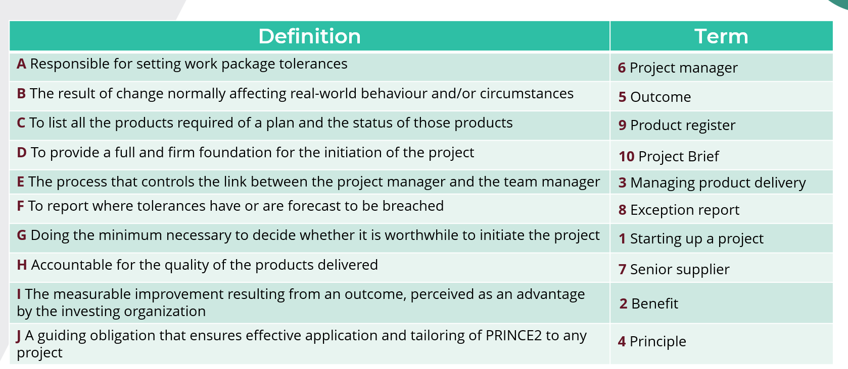

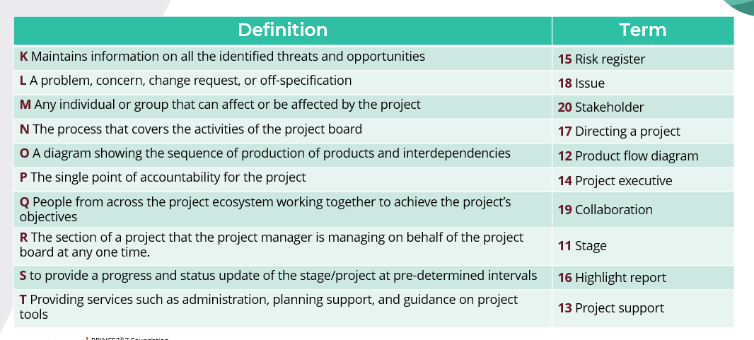

Videos:

**Difference between all Breakdown Structure(WBS), PBS, RBS and OBS**

[**https://www.youtube.com/watch?v=_OdF7VYic9I**](https://www.youtube.com/watch?v=_OdF7VYic9I)

Please try out these links for **free PRINCE2-Foundation Practice exam**

<https://www.itexams.com/info/PRINCE2-Foundation>

<https://www.projex.com/prince2-foundation-exam-2023-test-questions/>

<https://www.prince2training.com.au/prince2-foundation-sample-exam-questions/>

Additional Videos: Playlist

<https://www.youtube.com/watch?v=dstZ_8W_oUw>

E-books (PRINCE2)

<https://www.prince2-online.co.uk/courses/prince2-course-training/prince2-principles>

**PRINCE 2 videos :-**

1. PRINCE2 Mod 1 - Starting up a project process

<https://www.youtube.com/watch?v=r_NEljgFRWU>

2. PRINCE2 Mod 2 - Initiating a project process

<https://www.youtube.com/watch?v=cs6AxLA2I7E>

3. PRINCE2 Mod 3 - Controlling a stage process https://www.youtube.com/watch?v=qK0Kc7-

ryZQ&amp;t=331s

4. PRINCE2 Mod 4 - Managing product delivery process

<https://www.youtube.com/watch?v=METxq-XL8qc>

5. PRINCE2 Mod 5 - Managing a stage boundary process

<https://www.youtube.com/watch?v=IBflapUrRYw>

6. PRINCE2 Mod 6 - Directing a project process

<https://www.youtube.com/watch?v=LU0QoEZvVzg>

7. PRINCE2 Mod 7 - Closing a project process

<https://www.youtube.com/watch?v=EC1hZhwxxno>

8. PRINCE2 Mod 8 - Business case theme

<https://www.youtube.com/results?search_query=PRINCE2+Mod+8>

9. PRINCE2 Mod 9 - Organisation theme <https://www.youtube.com/watch?v=_bZNg-eGpAw>

10. PRINCE2 Mod 10 - Plans theme <https://www.youtube.com/watch?v=9AjKMNiiEX4>

11. PRINCE2 Mod 11 - Quality theme <https://www.youtube.com/watch?v=bXoZ5ywxtkk>

12. Mod 12 - Progress theme <https://www.youtube.com/watch?v=lHzdilUydqc>

13. PRINCE2 Mod 13 - Risk theme <https://www.youtube.com/watch?v=PKMK9qchIJY&amp;t=8s>

14. PRINCE2 Mod 14 - Change theme <https://www.youtube.com/watch?v=N2kHewSK49k>

15. PRINCE2 Mod 15 - Introduction to PRINCE2

<https://www.youtube.com/watch?v=zGeq5vOuS-I>

16. PRINCE2 Mod 16 - Tailoring and embedding

<https://www.youtube.com/watch?v=rG3AVbWEwXU>

17. PRINCE2 Mod 17 - PRINCE2 exam and accreditation

<https://www.youtube.com/watch?v=8e2x6zWtSR4>

We wanted to inform you that you will need to submit your exam request within 30 days of completing your course. Once your request is submitted, our relevant team will review the necessary details and proceed accordingly. After your exam request is processed, an exam voucher code will be provided to you, which you can use to schedule your exam directly with PeopleCert based on the available date and time slot.Here is a step-by-step guide to create account for redeeming your PeopleCert voucher.Step 1: Create an Account or Log InCreate an Account:If you do not already have an account with PeopleCert, visit the PeopleCert website.Look for the "Sign Up" or "Register" option and follow the prompts to create an account.Log In:If you already have an account, simply log in using your credentials.

Step 2: Complete Your ProfileNavigate to Your Profile:Once logged in, go to your profile section.Fill Out Required Fields:Enter all the necessary information, including your name, address, contact details, and any professional information that may be required.

Step 3: Verify Your Account

Verification Process:

Some platforms may require you to verify your account through an email or SMS verification process. Ensure you complete this step if prompted.

Step 4: Redeem the VoucherLocate Voucher Redemption Section:Find the section for redeeming vouchers. This might be under "My Exams," "Vouchers," or a similarly labeled section.Enter Voucher Code:Enter your voucher code in the required field, making sure to input it correctly.Step 5: Schedule Your ExamScheduling Option:After redeeming your voucher, look for a scheduling option within your account dashboard.Select Exam and Schedule:Choose the exam you wish to take.Select a date and time that fits your availability.If you have any questions or require further assistance, please do not hesitate to reach out to us. We are here to help in any way possible.Thank you for your attention to this matter